Week 11 Packet Tracer

Reflection: Home routers are powerful devices with many capabilities. We can get IP addresses manually (static) or by DHCP, which dynamically distributes values. Routers connect different networks within a network of networks (servers involved). The IP addressing for IPv4 allows us to reuse the 10 networks (17216, 19268) for a process called network address translation (NAT). This means that our end routers will have unique identifiable traffic for the rest of the internet to utilize despite only having a set amount of IP addresses and routers to cycle through for information.

Pings are Successful

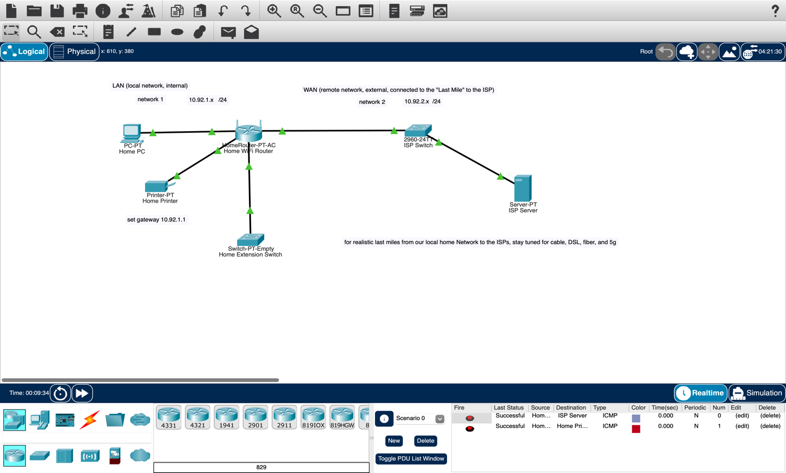
Ping echo request packet NAT-ed from Local to Remote network

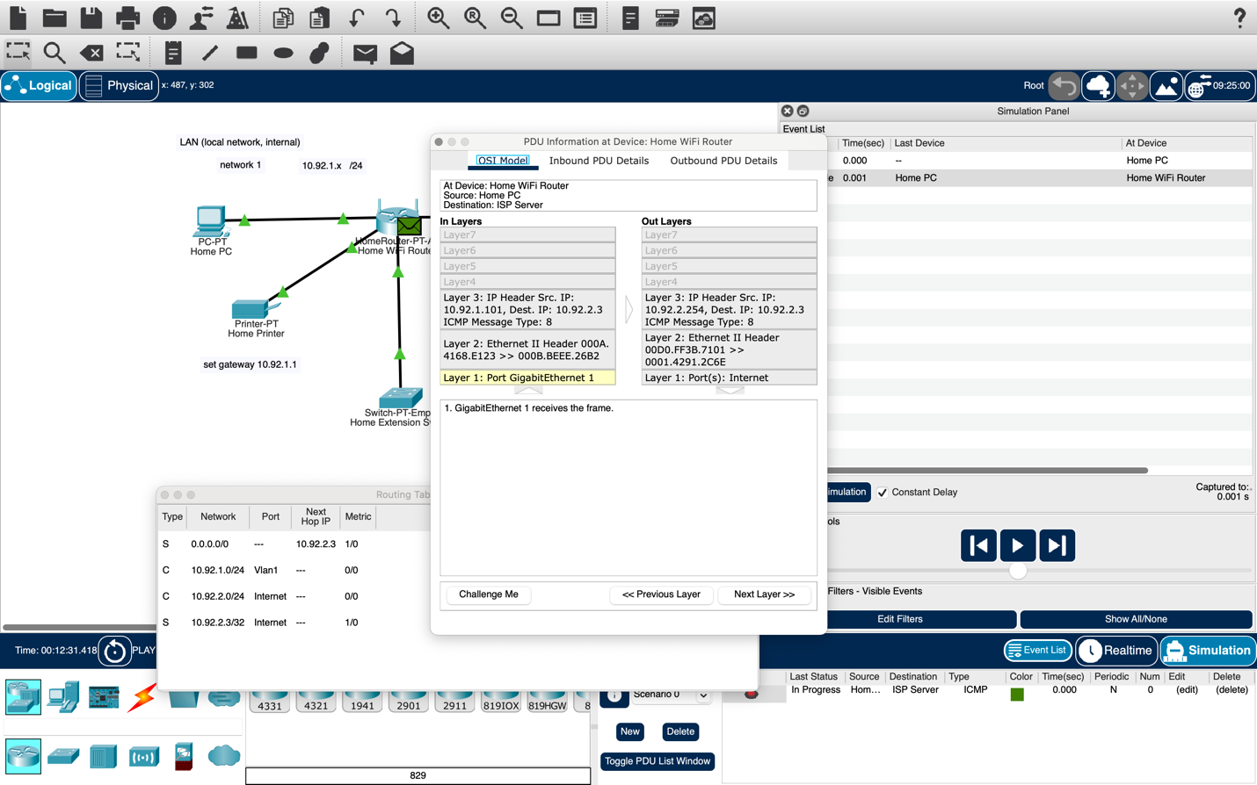
Ping echo reply packet NAT-ed on return from Remote to Local Network

